Gridfinity For Solidworks

I created this add-in for SolidWorks Design 2026 for Makers, as this is the version I use personally. I sincerely hope that it works for you as well.

This add-in mimics the GridfinityGenerator.com website as best as I could manage. This first version is a bit buggy when loading but works flawlessly.

- ) You will have to open a new Part first, as usual.

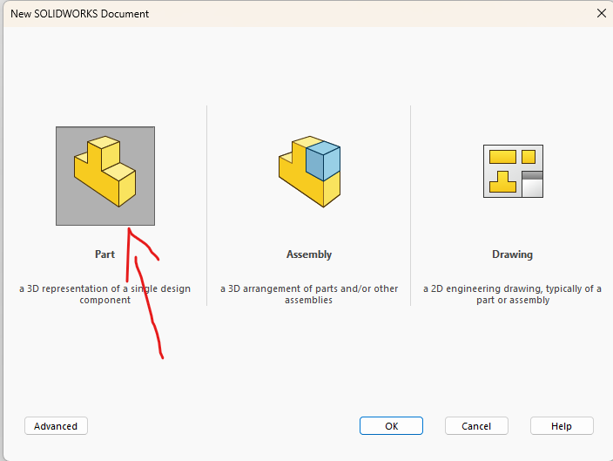

2.) Go to your "Tools" menu at the top.

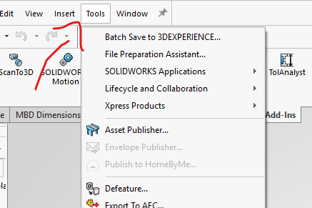

3.) Go all the way down to "Add-ins..."

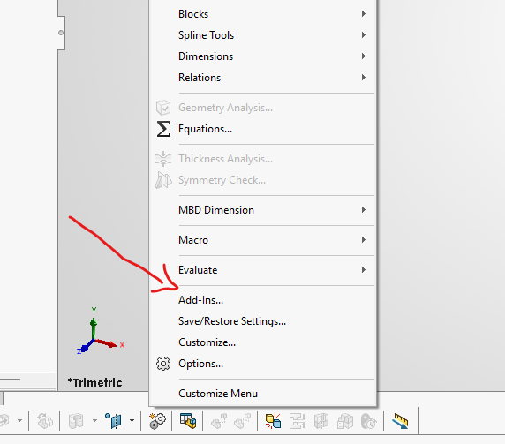

- ) The Add-ins pop-up opens. Scroll to the bottom and you will see your new “Gridlfinity Tray Builder” add-in. Uncheck the blue tick box by it and hit “OK”.

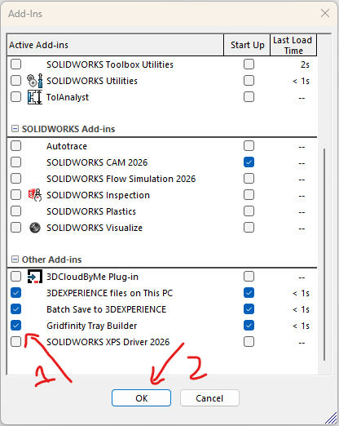

- ) Go back to Tools > Add-ins… and scroll to the bottom again, then recheck the box. Hit “OK”.

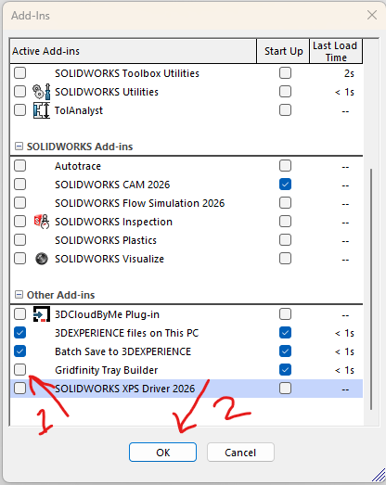

- ) Now, under the Tools menu, you should be able to see your new Gridfinity Add-in

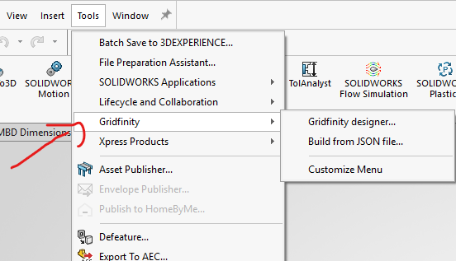

- ) Explore, have fun, and share this FOR FREE everywhere there is a need.
Gridfinity For Solidworks

